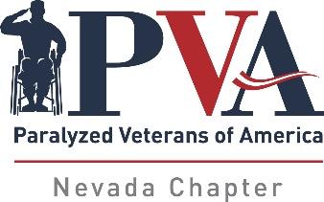
Paralyzed Veterans of America, Nevada Chapter
704 S. Jones Blvd.
Las Vegas, NV 89107
702/646-0040
702/646-3712 - fax
pvanevada@gmail.com
www.nevadapva.org

Policy Title: Step Outside Program (formerly Entertainment Reimbursement)

Date Adopted/Revised: August 8, 2007 (updated November 2018)

The Chapter will fund the member and one (1) guest for participation in or attending Basketball, Soccer, Bowling etc., events or will reimburse the member and one (1) guest to attend shows, movies, plays or lunch/dinner, in a sit-down “full service” restaurant. Not covered are receipts for fast food nor will we cover food via delivery service such as Uber Eats, Door Dash, etc.

The amount of funding will be capped at $100.00 per quarter per member.

In order to have access to these funds, the member must submit receipts, and a short review of the event attended, which will be placed in the newsletter. Receipts and the review must be submitted within three (3) weeks of having attended the event in order to be eligible for reimbursement.

This program is designed to get our members out and about in a social setting.

ADDENDUM: You do not need to spend $100.00 on any one event, the money is $100.00 per quarter so if you pay $10.00 ten times for movies you still get the funding. However, you must submit the receipt and the write-up within three weeks of the event. DO NOT SAVE YOUR RECEIPTS UNTIL YOU ACCUMULATE $100.OO, NEVADA PVA WILL KEEP TRACK OF THE FUNDS.

